**BidSpirit**

|  |  |  |
| --- | --- | --- |
| **SUPERVISOR** | **MUDASSIR ARIF** | |
| **BATCH** | **2309D** | |
| **GROUP** | BidSpirit | |
| **SERIAL NO** | **ENROLLMENT NO** | **STUDENT NAME** |
| **1.** | 1509566 | Shahzaib |
| **2.** | 1511648 | Muhammad Huzafia |
| **3.** | 1520286 | Mohit Kumar |
| **4.** | 1500600 | Muhammad Zeeshan |

***USER GUIDE***

- Welcome to Furniture House, your one-stop destination for a wide variety of quality furniture. The purpose of this websites is to provide you a different types of furniture’s like bed, sofas etc.., this user guide is designed to help you navigate through our website effortlessly.

***1. Top Layout***

This is the top /navbar of the website

* User can know more about the website by clicking on about us button.
* Users can also search what kind of furniture they want by clicking the search button on the right side



***2. Home Page***

* In this page users, 'll be greeted with a curated selection of furniture that spans styles and preferences. From cozy sofas to elegant dining sets, our Home Page showcases the best of what Furniture House has to offer. When user click the shop icon, they will see the modal of a specific furniture that the select.

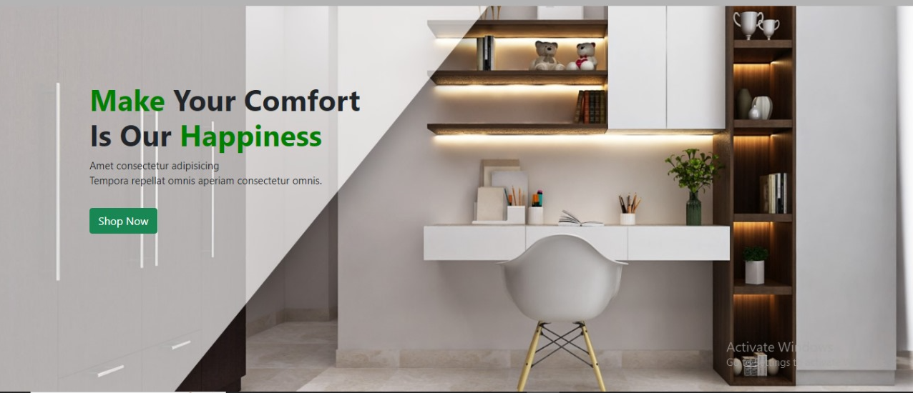

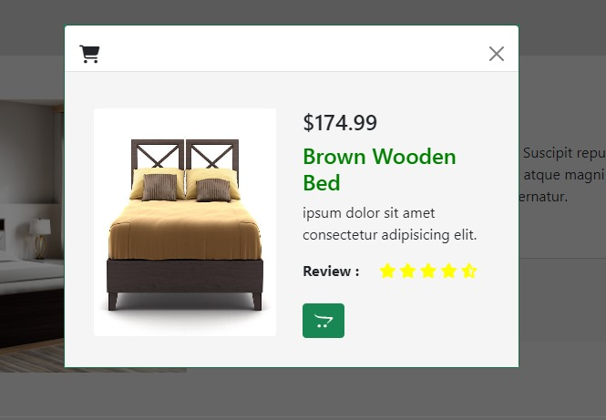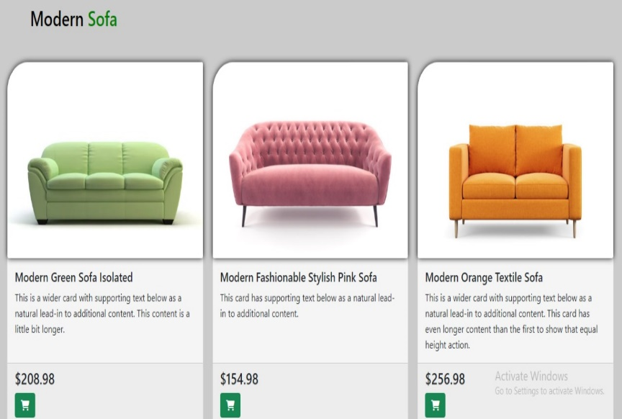

***3. New Arrival Page***

This is New arrival page

* 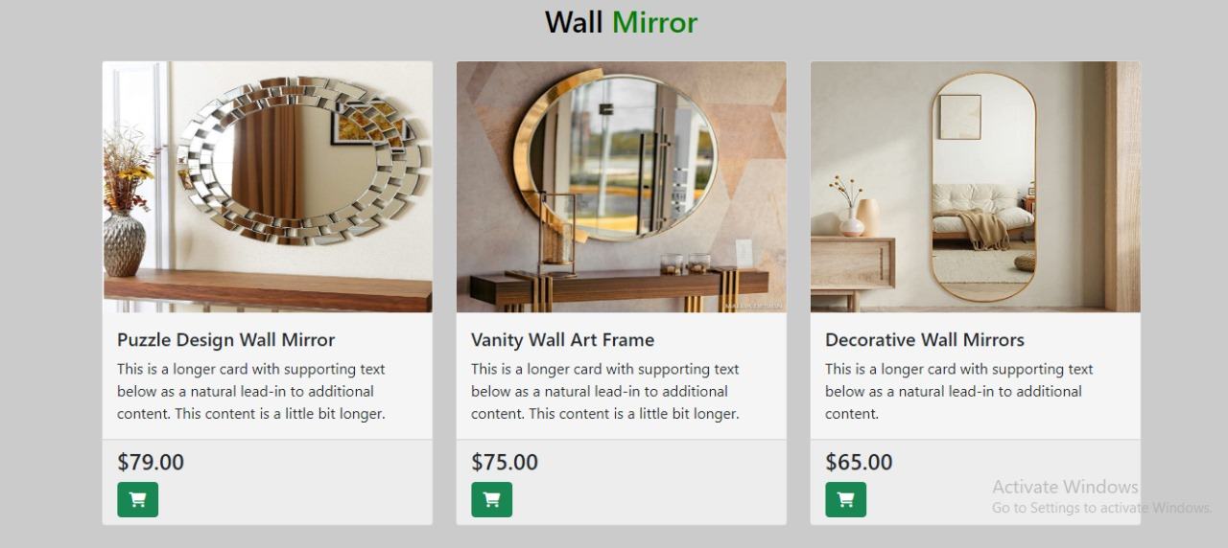In this page users can find a latest trends and designs of furniture’s. as we update this space regularly with our freshest additions.

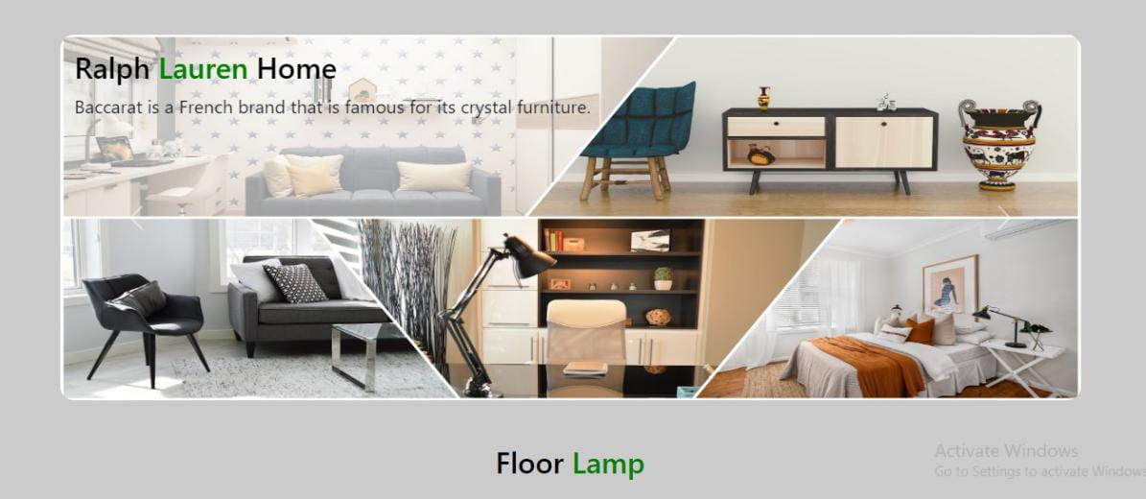

***4. About Us Page***

This is about page

* In this page users can get the detailed information about our website and get a sneak peek into who we are, our values, and our commitment to providing top-notch furniture that complements your lifestyle.

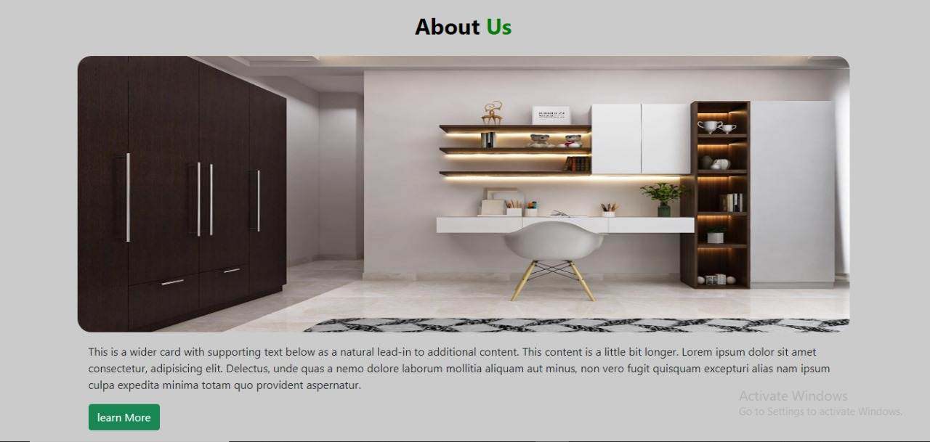

***5. Contact Us Page***

* This page connects the user with us
* User can leave their comments & messages too

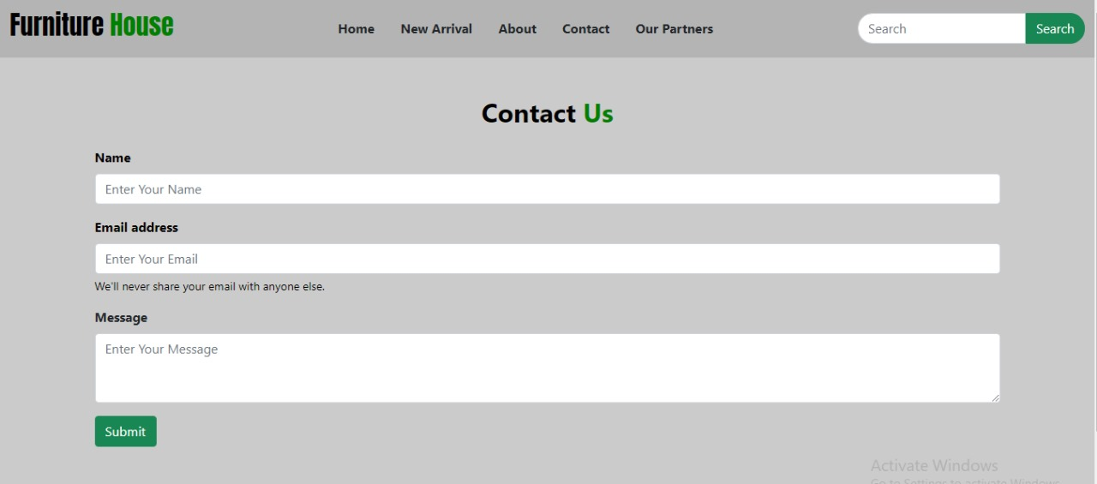

***6. OUR Team***

* In this page user can get information about who are the creators of this website.

